Stem Cell Therapy Enhances Neurological Recovery Following Spina Bifida Repair Surgery
June 28, 2015

Children born with spina bifida, or myelomeningocele (MMC), endure lifelong paralysis and suffer from severe cognitive disabilities. This is due to developmental defect which leaves the spinal cord exposed to intrauterine damage and while in utero surgical repair has met with some success in reversing motor function deficits [1] this procedure does not completely restore neurological function. This led researchers from the laboratory of Diana L. Farmer (University of California, Davis, USA) to investigate if mesenchymal stem cell therapy (MSC), known to improve endogenous repair of damaged tissues [2], could augment and enhance the outcome of surgical repair. Their new study, published in Stem Cells Translational Medicine, finds that the application of early gestation human placental mesenchymal stromal cells (PMSCs) [3] can significantly and consistently improve neurological function in an ovine MMC model [4].
The PMSCs utilized displayed tri-lineage differentiation potential (osteogenic, adipogenic and chondrogenic) and, after culture in a three-dimensional collagen hydrogel, secreted paracrine factors involved in angiogenesis, chemotaxis, extracellular matrix remodeling and the innate immune response. Additionally, PMSCs expressed neural and stem cell-related markers and secreted high levels factors involved in neurogenesis, neuroprotection and angiogenesis. The researchers then created MMC-defects in 12 fetal lambs [5], and repaired the defect approximately 30 days later with or without the addition of PMSCs in a collagen gel over the affected region. At birth (around 40 days later) the lambs in the PMSC-treated group had significantly higher overall neurologic scores (See figure), with 4/6 being able to walk independently as compared to none in the group of lambs who did not receive PMSCs. Assessment of the lumbar spinal cord found no significant differences in spinal cord cross-sectional area, degree of deformation, or proportional area of gray or white matter, although PMSC-treated lambs did display a larger density of large neurons, with a significant positive association between large neuron density and motor function recovery. The authors did not however find any evidence of migration or integration of PMSCs into the spinal cord or surrounding tissue, and found no signs of tumor formation or abnormal growths.
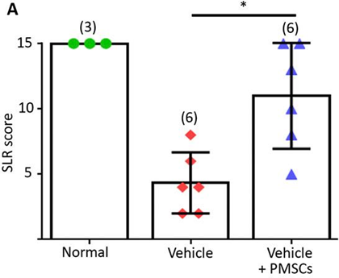
The authors suggest that stem cell therapy in this case complements the currently utilized surgical approach and protects neural tissue, thereby inhibiting and/or repairing motor defects. This is a significant improvement on a previous study which found little or no significant effects after injecting murine neural stem cells into the ovine spinal cord after MMC defect creation [6]. Although no mechanistic insights into the process by which PMSCs effect this improvement are discussed, this preclinical success will hopefully translate into a future clinical trial to improve spina bifida related paralysis.
References
- Adzick NS, Thom EA, Spong CY, et al. A randomized trial of prenatal versus postnatal repair of myelomeningocele. The New England journal of medicine 2011;364:993-1004.
- Liang X, Ding Y, Zhang Y, et al. Paracrine mechanisms of mesenchymal stem cell-based therapy: current status and perspectives. Cell transplantation 2014;23:1045-1059.
- Jones GN, Moschidou D, Puga-Iglesias TI, et al. Ontological differences in first compared to third trimester human fetal placental chorionic stem cells. PLoS One 2012;7:e43395.
- Wang A, Brown EG, Lankford L, et al. Placental mesenchymal stromal cells rescue ambulation in ovine myelomeningocele. Stem Cells Translational Medicine 2015;4:659-669.
- von Koch CS, Compagnone N, Hirose S, et al. Myelomeningocele: characterization of a surgically induced sheep model and its central nervous system similarities and differences to the human disease. Am J Obstet Gynecol 2005;193:1456-1462.
- Fauza DO, Jennings RW, Teng YD, et al. Neural stem cell delivery to the spinal cord in an ovine model of fetal surgery for spina bifida. Surgery 2008;144:367-373.

